**“PyCalculator” User Guide**

This document guides you in how to use the application “PyCalculator”.

1. Open the file “PyCalculator.exe” by going to the folder where that file is saved in after you downloaded it. Below shows how the file icon looks like (see the file circled in red).

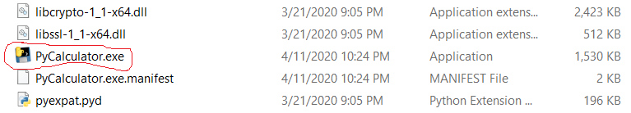

1. Below shows what is initially shown when you have double clicked the application.

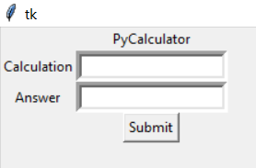

1. Below shows what happens if you type in a calculation.

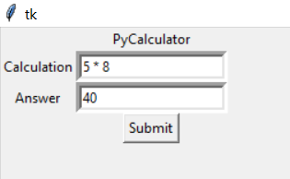

1. You can also use Python’s mathematical functions from ‘math’ library (e.g. ‘sin(x)’, ‘cos(x)’, and ‘tan(x)’ where x is in radians) for your calculation. To see more Python’s functions from ‘math’ library, go to <https://docs.python.org/3/library/math.html>. In the screenshot below, sin(pi/2) where pi/2 is in radians is 1.

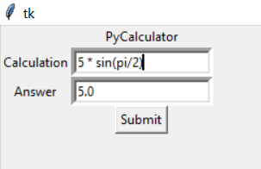

1. You can also use Python’s Decimal class for your calculation (e.g. Decimal(x) where x can be a string or a number). Information about Python’s Decimal class can be found in <https://docs.python.org/2/library/decimal.html>. The screenshot below shows an example of Decimal class usage.

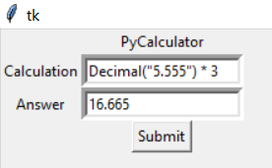

1. Below shows a more complex calculation (i.e. a calculation with more than one sign).

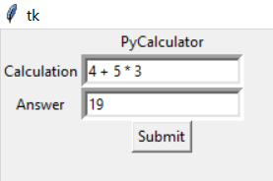

1. Below shows a warning when you enter a calculation which is invalid.

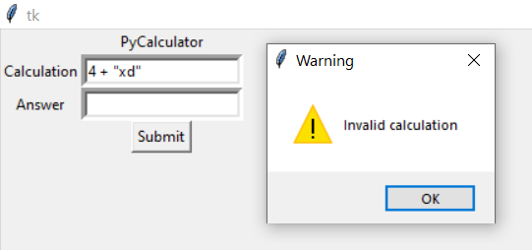

1. The “X” button at the top right of the application window (shown at the top right of the screenshot below) can be pressed to exit the application.

